Q2. Draw the DC load line for both the circuits and show the Q-point.
Answer:
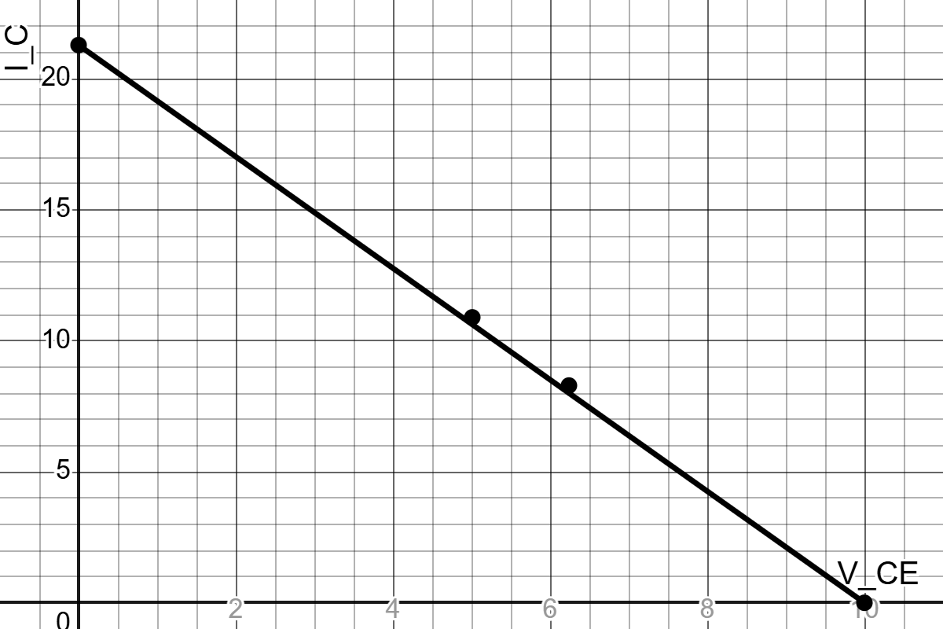
Fig G.1: DC load line and Q-point of Circuit-6.1 (Fixed Biasing)

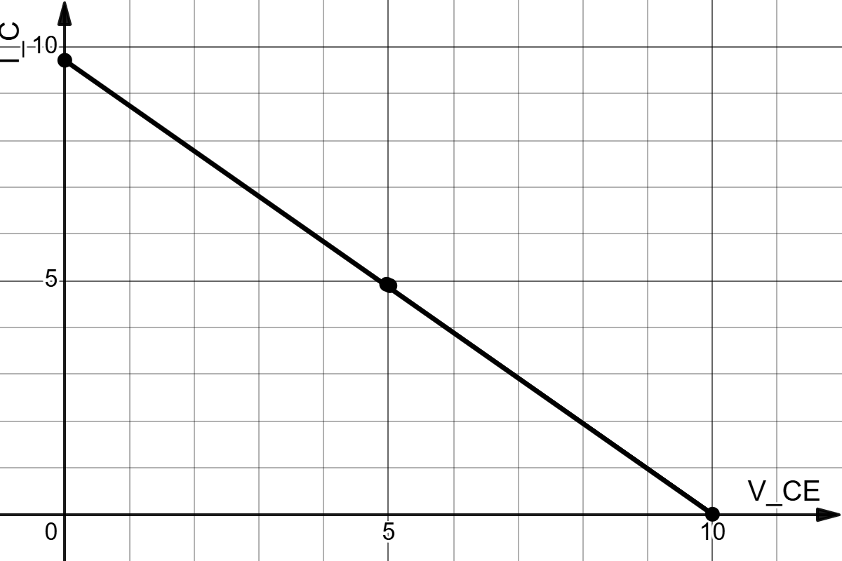
Fig G.2 : DC load line and Q-point of Circuit-6.2 (Self Biasing)

